Lab 2 - Patch Management

Brandon Trinkle

Arizona State University

IFT 380

Professor Shaun Usman

January 26, 2025

Lab 1 – Patch Management

1. In Configuration Manager, go to 'Automatic Deployment Rules' within 'Software Library' section, and study the existing 'EndPoint Definitions' present. Look at it's Properties, and see the Deployment Settings to see what collections it applies to. Where is it deployed and why?
   1. It is deployed everyday at midnight.

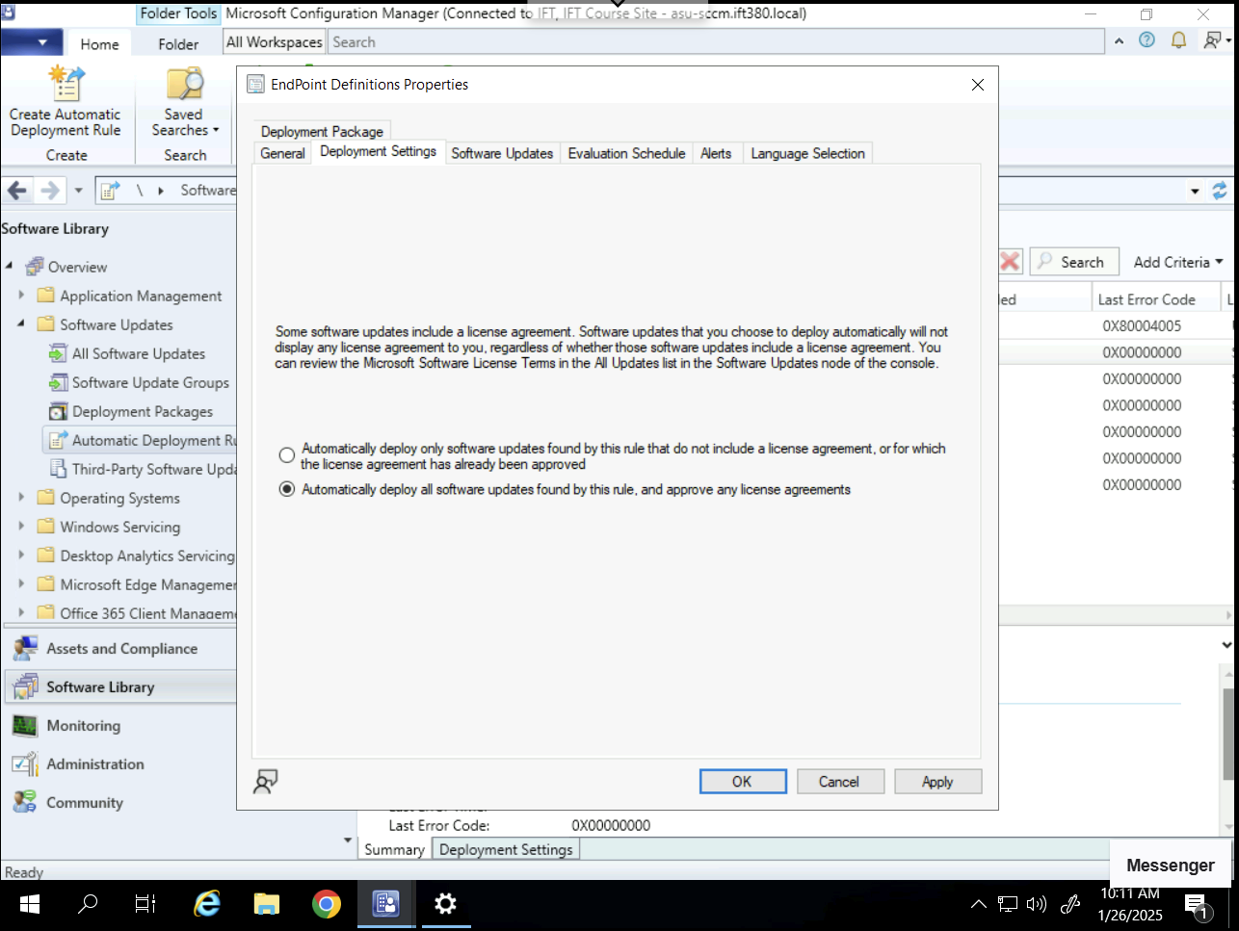

1. You can add 'Superseded' = No -- what does this mean? You can add 'Required' = Yes -- what does this mean? Answer these questions in your writeup (whether you use them or not).
   1. Superseded means that Microsoft has replaced the existing application with a new one. By selecting no, you are telling Microsoft to only include updates that are still current, not ones replaced by a newer version.
   2. Required means that the update applies to the device, and is not installed yet. By selecting yes, Configuration Manager will pull updates that only the targeted system needs. If the update is already installed or not applicable, the update would not be considered “required”.

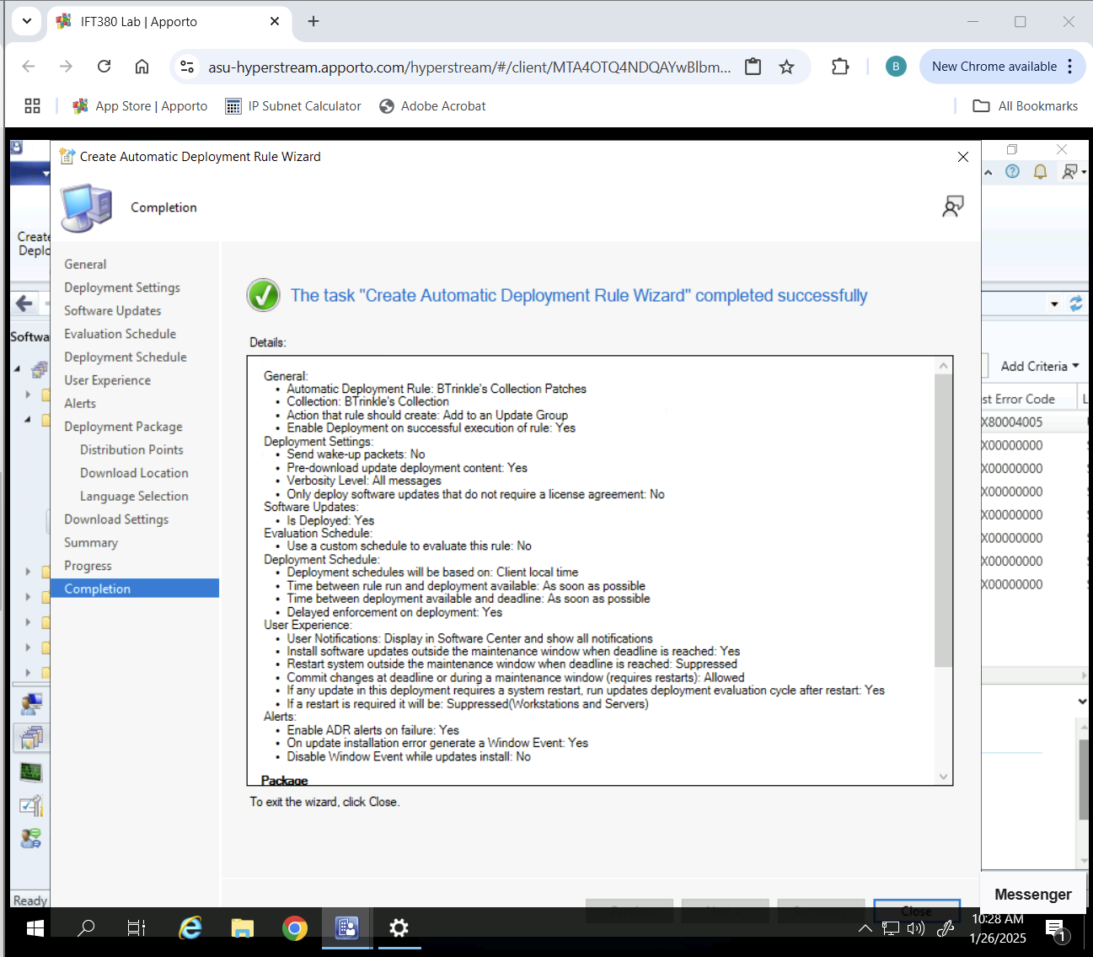

1. Add maintenance window and display screenshot showing deployment section.

*Note: Maintenance window*

*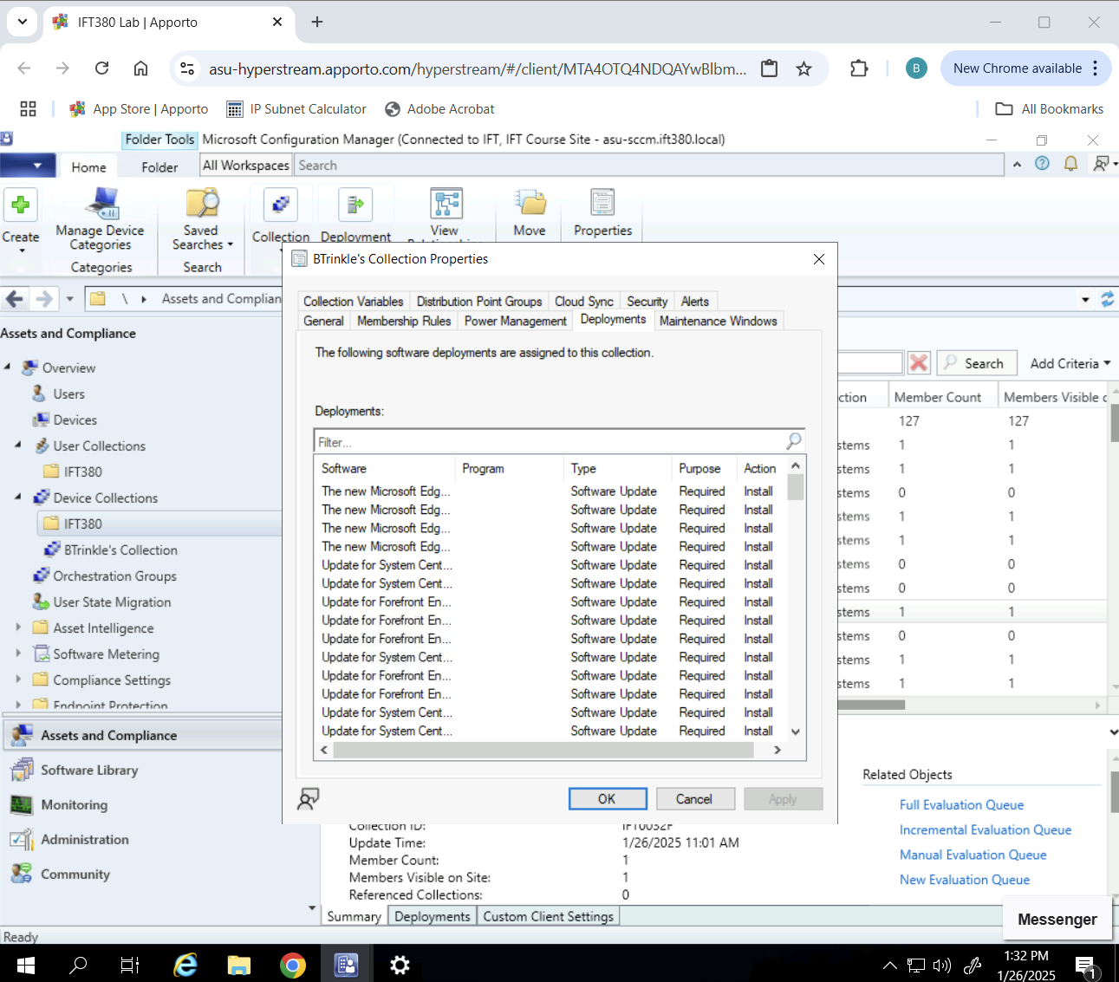*

*Note: Deployment tab*